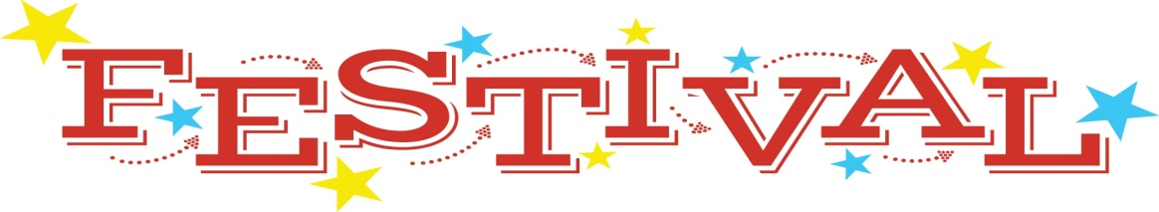

Fall Festival wristbands are now on sale for a discounted price! Please fill out this form and return it with the money in an envelope labeled Fall Festival Wristbands. We will send the wristbands home with your child in a sealed envelope. Adults do not need to purchase a wristband. The wrist band will allow your child to play unlimited access to all games, activities, and bounce houses.
*To clarify, if your family has 3 or more children and you purchase your armbands in advance, your total cost would be $20.00*

1 Band ……………. $10.00
2 Bands ………….. $15.00
3+ Bands ……….. $20.00
Tickets will be $10.00 each if purchased at the Fall Festival.
Child’s Name: _________________________________________________________________________
Number of Wristbands: ________________________________________________________________
Child’s Teacher: _______________________________________________________________________

Fall Festival wristbands are now on sale for a discounted price! Please fill out this form and return it with the money in an envelope labeled Fall Festival Wristbands. We will send the wristbands home with your child in a sealed envelope. Adults do not need to purchase a wristband. The wrist band will allow your child to play unlimited access to all games, activities, and bounce houses.

1 Band ……………. $10.00
*To clarify, if your family has 3 or more children and you purchase your armbands in advance, your total cost would be $20.00*

2 Bands ………….. $15.00
3+ Bands ……….. $20.00
Tickets will be $10.00 each if purchased at the Fall Festival.
Child’s Name: _________________________________________________________________________
Number of Wristbands: ________________________________________________________________
Child’s Teacher: _______________________________________________________________________

