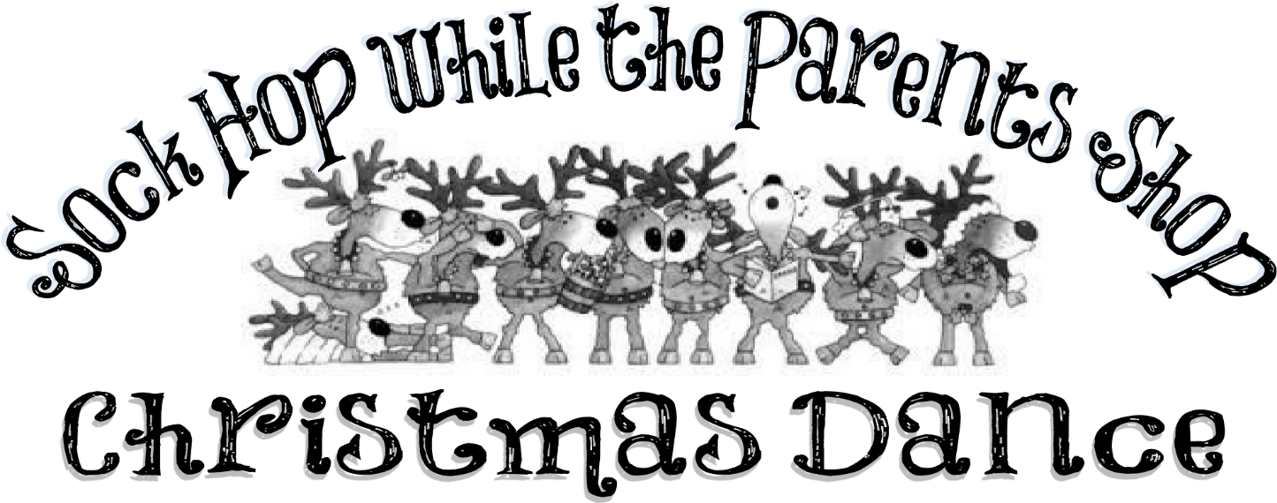

Are you needing to get some Christmas shopping done without your kids around? Let us help! The PTO is having a “Sock Hop while the Parents Shop” Christmas Dance! The gymnasium will be lit up with dance floor lighting and a DJ will keep the festivities going with popular dance songs (PG of course) and karaoke! It will be AWESOME! And finally, the PTO, parent volunteers, and Walker Valley High School students will be supervising.

Parents will get some of their shopping done, kids have a blast at a supervised karaoke & dance Christmas party, and we’ll get a little closer to our Chairs for Excellence goal! It’s a win-win…win!

When: Saturday, December 13, 2014 from 1:00 to 6:00 pm.
Cost: Tickets are $5 and MUST be bought in advance! Tickets will be NOT be sold at the door. Drinks, popcorn, & hotdogs will be available for $1 each at the dance.
Tickets: Fill in the information below. Return the slip & your money in a plastic baggie or sealed envelope labeled with your child’s name, grade, & teacher. Tickets will be sent home in the same envelope or baggie.
If you have any question, please feel free to contact Tina at 423-790-6650 or Trish at 423-336-2232. As always, your support for Charleston Elementary and the PTO is much appreciated!

Child(rens) Name(s):

Child(rens) Teacher(s):

Number of Tickets: ___________ Amount of $ Sent: ____________

